TRƯỜNG ĐẠI HỌC BÁCH KHOA
ĐẠI HỌC QUỐC GIA TP HỒ CHÍ MINH



HOMEWORK
MẠNG MÁY TÍNH (THỰC HÀNH) – LAB 7

Giảng viên hướng dẫn: Ths. Bùi Xuân Giang

Sinh viên thực hiện: Trần Minh Tân

Mã số sinh viên: 2012018

Lớp: L10.

Thành phố Hồ Chí Minh – 2022

PART 2. Beacon Frames
1. What are the SSIDs of the two access points that are issuing most of the beacon frames in this trace?
They are “30 Munroe St” and “linksys12”.
2. What are the intervals of time between the transmissions of the beacon frames the linksys_ses_24086 access point? From the 30 Munroe St. access point? (Hint: this interval of time is contained in the beacon frame itself).
They are both 0.601687 – 0.499197 = 0.10249
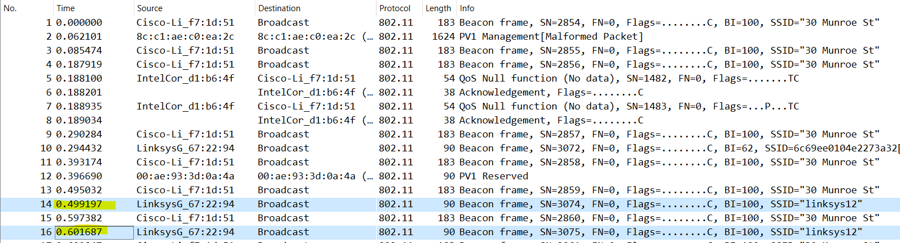
3. What (in hexadecimal notation) is the source MAC address on the beacon frame from 30 Munroe St? Recall from Figure 7.13 in the text that the source, destination, and BSS are three addresses used in an 802.11 frame. For a detailed discussion of the 802.11 frame structure, see section 7 in the IEEE 802.11 standards document (cited above).
Source MAC address: (00:16:b6:f7:1d:51) 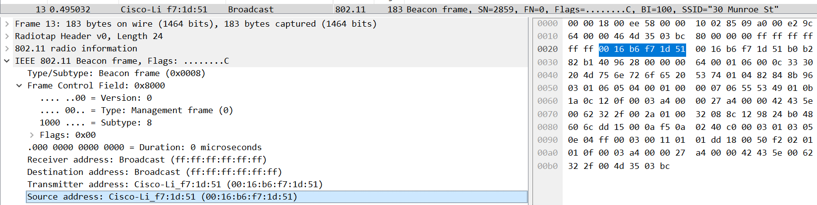
4. What (in hexadecimal notation) is the destination MAC address on the beacon
frame from 30 Munroe St??
Destination MAC address is ff:ff:ff:ff:ff:ff
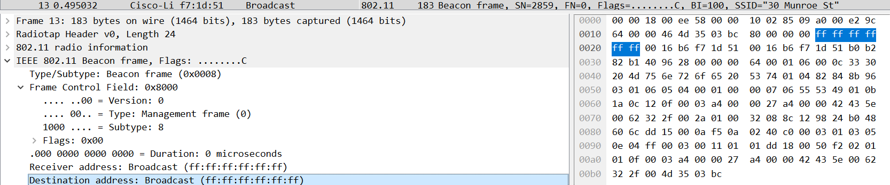
5. What (in hexadecimal notation) is the MAC BSS id on the beacon frame from 30
Munroe St?
The MAC BSS id is 00:16:b6:f7:1d:51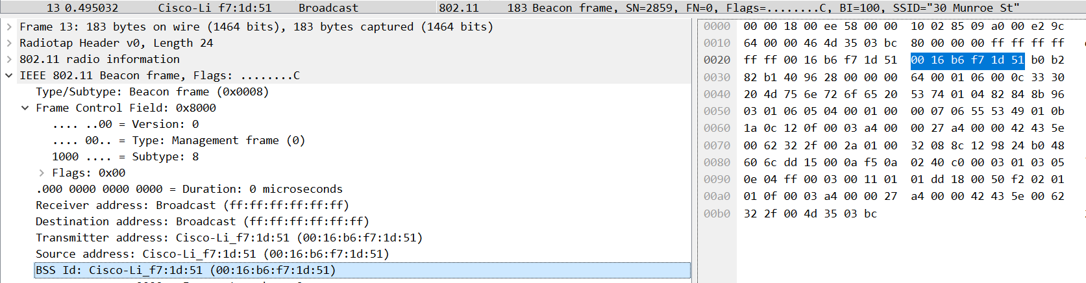
6. The beacon frames from the 30 Munroe St access point advertise that the access
point can support four data rates and eight additional “extended supported rates.”
What are these rates?
The eight additional “extended supported rates” are 6.0, 9.0, 12.0, 18.0, 24.0, 36.0, 48.0, 54.0 Mbps and four data rates are 1.0, 2.0, 5.5, 11.0 Mbps.
PART 3. Data Transfer
7. Find the 802.11 frame containing the SYN TCP segment for this first TCP session (that downloads alice.txt). What are three MAC address fields in the 802.11 frame? Which MAC address in this frame corresponds to the wireless host (give the hexadecimal representation of the MAC address for the host)? To the access point? To the first-hop router? What is the IP address of the wireless host sending this TCP segment? What is the destination IP address? Does this destination IP address correspond to the host, access point, first-hop router, or some other network-attached device? Explain.
Solution:
Find the 802.11 frame containing the SYN TCP segment for this first TCP session (that downloads alice.txt). What are three MAC address fields in the 802.11 frame?
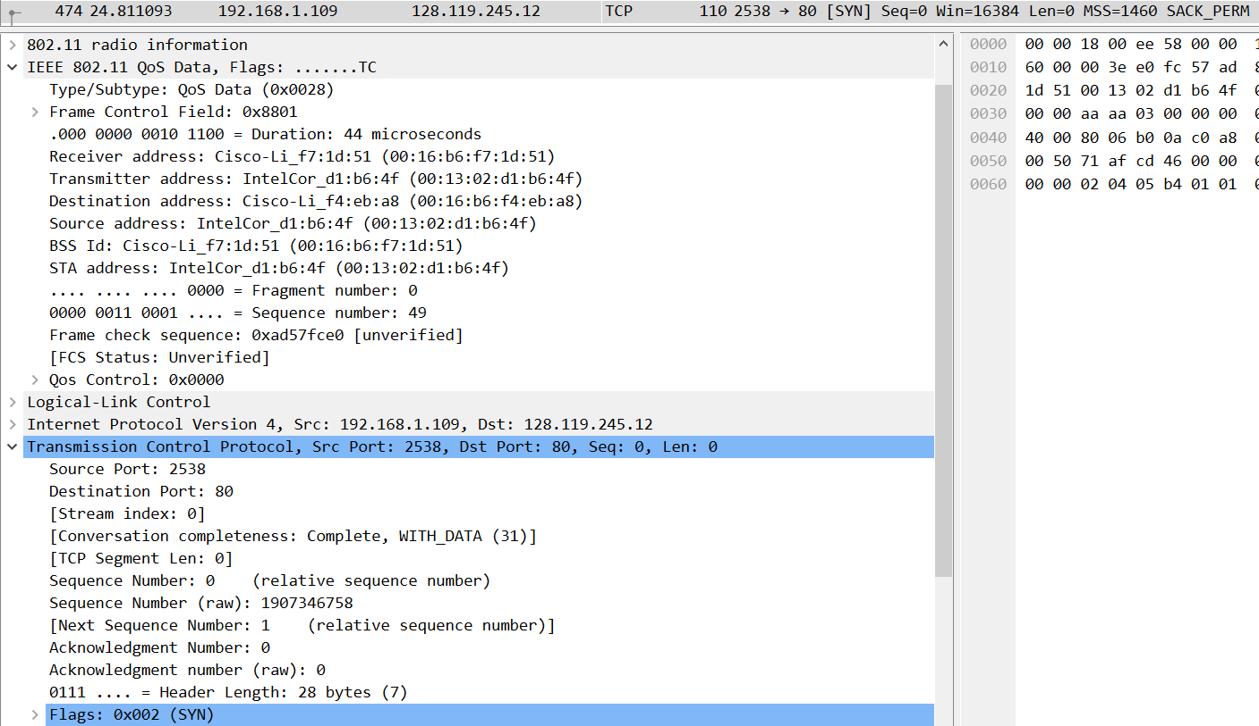
This frame is at t = 24.811093.
Three MAC address fields in the 802.11 frame are BSS id, source address and destination.
Which MAC address in this frame corresponds to the wireless host (give the hexadecimal representation of the MAC address for the host)? To the access point? To the first-hop router?
The MAC address corresponds to the wireless host is 00:13:02:d1:b6:4f.
Corresponding to the first hop router is 00:16:b6:f4:eb:a8.
Corresponding to the wireless host sending this TCP segment is 00:16:b6:f7:1d:51.
What is the IP address of the wireless host sending this TCP segment? What is the destination IP address? Does this destination IP address correspond to the host, access point, first-hop router, or some other network-attached device? Explain.
The corresponding IP of the wireless host is 192.168.1.109.
The destination IP is 128.199.245.12 and this IP is corresponds to the host.

